Memphis-Shelby County Schools
160 S. Hollywood Street • Memphis, TN 38112 • www.scsk12.org

Dear Parent/Legal Guardian,

If you are receiving this letter, your child has an incomplete vaccination record that must be completed to remain in school. To assist you in becoming compliant, we are offering you the opportunity to have your child vaccinated at their school during school hours, with your permission and consent.

In cooperation with the Shelby County Health Department, MSCS will provide a time that the nurses will be at your child’s school to provide vaccinations. Another option is to go to the Shelby County Health Department on the 1st and 3rd Saturdays of each month, from 9-12pm, to receive the vaccines.

We need you to complete the Vaccine Consent form, and after vaccination, you will receive a Shot Record for your records. Please scan and complete the QR code for the electronic form. If you do not have access to the electronic form, please fill out and return the paper consent form by Friday.
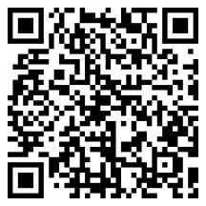
If you have questions and/or concerns, please contact your school.

